Practical - 6
Practical Title: MySQL Schema Design, ER Model, PDO Connectivity, and Prepared Statements
Design the database for StudentHub with students, events and registrations. Create PHP database connection using MYSQL statements.

Theory
1. Is the schema normalized properly?
Yes. The database is divided into separate tables such as Students, Events, and Registrations. This avoids duplicate data and ensures that each table stores information related to a specific entity. The Registration table connects students and events.
2. Are primary keys and foreign keys correctly defined?
Yes. Each table has a unique primary key to identify its records. The foreign keys in the Registration table refer to the Student and Event tables, maintaining the relationship and data integrity between the tables.
3. Is the database connection handled securely?
Yes. The PHP database connection uses PDO with exception-based error handling. Prepared statements can be used for database queries to prevent SQL injection. Database credentials should also be kept separate from other application code and should not be exposed to users.

Evidence of Work (Screenshots)
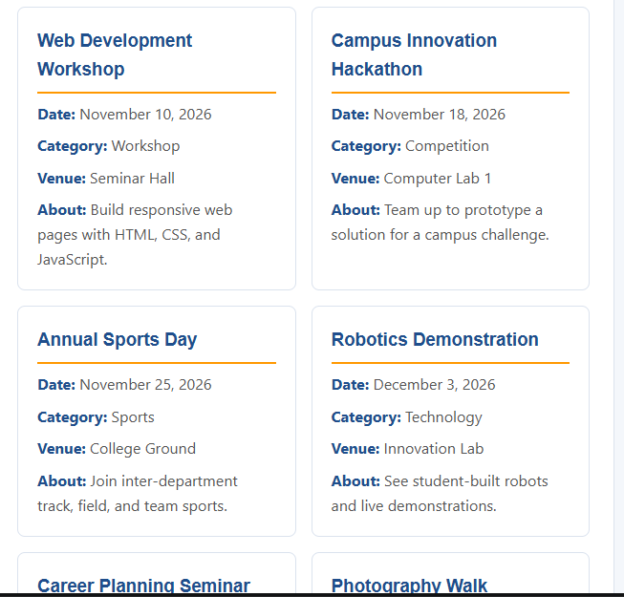
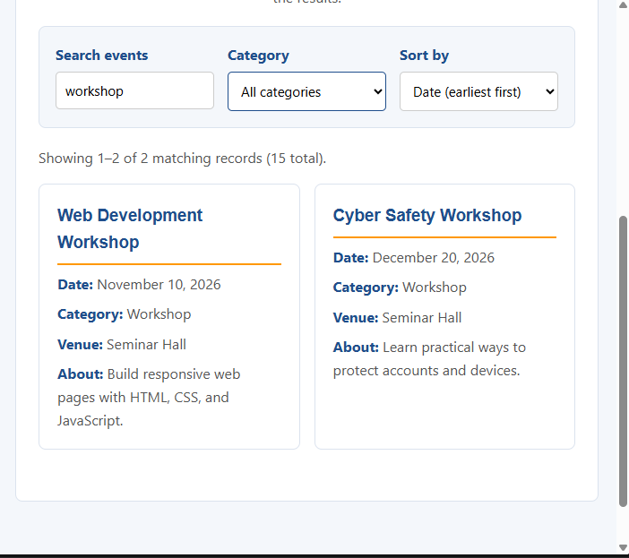

Description:
• Schema Normalization:
The database is divided into separate tables for students, events, and registrations. This reduces data duplication and keeps the database organized.
• Primary and Foreign Keys:
Each table has a primary key that uniquely identifies every record. Foreign keys are used in the registrations table to connect students with events and maintain relationships between the tables.
• Secure Database Connection:
The PHP application uses PDO to establish a database connection. Error handling is used to manage connection failures, and prepared statements can be used to protect database queries from SQL injection.

GitHub Repository Link:

https://github.com/archibhatt091601

Challenges Faced
- Database design: Deciding how to divide the StudentHub data into separate tables for students, events, and registrations was challenging.
- Relationships: Understanding and correctly implementing relationships between tables using foreign keys required careful attention.
- Primary and foreign keys: Defining the keys correctly and maintaining data integrity was a challenge.
- PHP-PDO connection: Setting up the connection between PHP and MySQL and handling connection errors required debugging.
- Prepared statements: Understanding how prepared statements are used for secure database operations was initially challenging.
- Testing: Testing the database connection and checking whether the tables and relationships worked correctly required multiple checks.

Learning Outcome
After completing this practical, I learned how to:
- Design a normalized MySQL database for a web application.
- Create tables using MySQL and insert seed/test data.
- Define primary and foreign keys to maintain relationships and data integrity.
- Create an ER model to represent relationships between students, events, and registrations.
- Connect PHP with MySQL using PDO.
- Handle database connection errors using exception handling.
- Understand prepared statements and their importance for secure database queries.
- Use phpMyAdmin and XAMPP to create, manage, and test the database.

Faculty Remarks: (Keep this blank for faculty)

